Email: sandy@belladomain.com Location: San Francisco, CA
Phone: 415.613.8508 Website: belladomain.com
Twitter: @sandyjk

Brief Biography of Sandy Jones-Kaminski
Sandy Jones-Kaminski is the author of "I'm at a Networking Event--Now What???" , the #1 business book on the 2010 Inc.com Holiday Gift Guide Wish List and is a former VP of Networking for a major national professional development association. Today, Sandy is the Chief Connecting Officer and Principal Consultant of Bella Domain Media where she shares her practical advice and hard-earned insights on effective networking, LinkedIn and personal branding via webinars, panels, keynotes, one-on-one consulting, her blog and interactive workshops. Sandy has been a columnist for WomenEntrepreneur, The Salary Reporter on PayScale.com, Business 2 Community, BlogHer and onTargetjobs. She has been featured on Fox Business News, NWJobs, The Creative Career, Successful Women Talk, Work Goes Strong, Yahoo! Small Business, Bankrate.com, You're Hired! and My Global Career. You can follow Sandy on Twitter: @sandyjk or learn more at www.belladomain.com.
Additional Biography info:
Sandy has more than 15 years of experience in business development, marketing, sales channel creation and partner/client/affiliate relations for Software as a Service (SaaS) and business services companies.
Prior to becoming a San Francisco-based consultant in 2001, Sandy led the strategic partner program as an executive director and regional sales manager for TriNet, a business process outsourcing company based in the San Francisco Bay Area. In this role, Sandy was responsible for managing business development programs with partner sales teams and channels.
Previously, Sandy was also a VP-level operations executive within the business intelligence arena. First working at Information Resources, Inc., and then at Strategic Media Research, both in Chicago.
Sandy has been a trainer and member of Women In Technology International (WITI), a board member for one of the largest American Marketing Association chapters in the U.S. and often volunteers as a mentor. She is a popular keynote speaker and the founder of Bella Domain Media’s Pay It Forward Party as well as a former Chicago Greeter. She has received executive level training and participated in continuing education programs via a number of institutions and locations, including the University of Chicago, SAS Institute and Harvard Business School. You can follow Sandy on Twitter @sandyjk or learn more at www.belladomain.com.

About Sandy’s Book
Need help to expand your business perspectives? Find employment? Make contact with that one person who can open doors for you? Are you connecting with the right people? Are you or the people you work with somewhat challenged when it comes to networking at events?
“I'm at a Networking Event--Now What???” illustrates that today's social networking environments practically demand that you have at least some knowledge of effective networking practices in order to achieve the results most of us are looking for.
Through this book, you will learn how to make quality connections, cultivate relationships, expand your circle of influence through networking events, and create good "social capital." You'll also find information on networking tools and technology that will promote new contacts and connections.
For some, this book will serve solely as a reminder, but for many, it will offer new valuable insights on what to do, and just as importantly, what not to do while you're out there working hard to maintain good standing within your social networks (on-line or otherwise), and striving to grow and nurture your own invaluable social capital. You'll also learn why you might want to consider becoming a "pay it forward" focused person, as well as how to be more memorable. By the end of the book, you should feel empowered to take matters into your own hands and approach networking with a plan to achieve your goals.
"If you want a great read with awesome advice on networking, then this book is a must on your shelf. Sandy offers a truckload of practical `how to' strategies, tips, insights, best practices and example to illustrate her points. Her pay-it-forward approach is a revolutionary idea I found especially intriguing. If you're struggling for ways to expand your professional contacts and relationships, you'll find lots of answers in the pages of this excellent book." - Alan Collins, former Vice President of Human Resources at PepsiCo and Author of Unwritten HR Rules
“I’m at a Networking Event — Now What??? is a terrific resource for anyone who has to go to any kind of networking event for the purpose of… networking! – Jason Alba, Jibber Jobber
“Whether you’re a rookie or an old pro at the networking game, I guarantee you’ll walk away from this book with some new ideas, tools, and tactics that will help you be more successful!” - Matt Youngquist, Career Horizons
Reviews of the Book
Amazon.com JibberJobber.com Career-Horizons.com Career-Resumes.com
About the Publisher:
Happy About® is a California corporation, is located in the heart of Silicon Valley.
Links to Sandy Jones-Kaminski and Book
LinkedIn Profile Amazon.com Bella Domain Media
Twitter.com/SandyJK Facebook Fan Page

Select Media Coverage (more press here):

Inc.com: Holiday Gift Guide 2010: My Business Books Wish List (Ranked #1)
PR.com: Ever Been Nervous at a Networking Event? Read This New Book.
Seattle Times: Hire Ground - Helping Job Seekers By “Paying It Forward”
Biznik.com: What Should You NOT Do At A Networking Event?
Seattle 2.0: PSAMA: Offer Some Help, Get Some Help
Success In HR: Pay-It-Forward: An Awesome Strategy for Networking in Human Resources…
Seattle Times: Hire Ground – Networking Event Advice for Social Wallflowers
Bankrate.com: 5 Networking Strategies to a New Job
Daily Journal of Commerce: Here's the secret of successful networking: It's not all about you
Business Examiner: Networking at the gym becomes standard play for those who meet regularly
Career Resumes: Book review

Select List of In-Person Speaking Engagements and “Pay It Forward” Parties
2/10/10 – Silicon Valley Marketing/Sales/Business Development Meet-up – Cupertino, CA
2/11/10 – San Francisco Bella Domain PIF Party/Book event – Roe, San Francisco, CA
4/08/10 - SMPS Denver Presents: A Pay It Forward Party Networking Event - Denver, CO
4/30/10 – Toast of Seattle Chamber Networking Event and PIF Party – Hard Rock Café, Seattle, WA
11/10/10 – Pay It Forward Party/Networking Event – NextSpace – San Francisco, CA
2/17/11 – Pay It Forward Party/Networking Event – Bay Club Financial District – San Francisco, CA
6/16/2011 - CSIX Connect - 12 Rules of Effective Networking Presentation - Saratoga, CA
6/30/11 – You're Hired! TV Show, Pacifica Community Television – San Francisco, CA
2/08/12 - A Pay It Forward Party Networking Event: Show Your Network Some LUV – San Francisco, CA
3/13/12 - San Francisco Professional Career Network - How to Use LinkedIn in Your Job Search – San Francisco, CA
05/15/12 – San Francisco Professional Career Network – LinkedIn Profile Audit: Polish Your LinkedIn Profile – SF, CA
06/18/12 – OHUG 2012 Global Conference – Making the Most of Your Time at OHUG 2012 – Las Vegas, NV
06/19/12 – OHUG 2012 Conference Keynote – Cultivating Connections & Networking Effectively at OHUG 2012 – LV, NV
04/22/13 – HR West 2013 – Cultivating Connections & Networking Effectively at HR West ’13 -- Oakland, CA
07/22-23/13 – CRTCA 2013 Annual Conference – multiple sessions – Chicago, IL
07/25/13 – BlogHer ’13 Annual Conference – Welcome & Newbie Networking Workshop – Chicago, IL
10/18/13 – Women in Consulting (WIC) – 12 Rules of Effective Networking: Making Connections Matter – Menlo Park, CA

Images are on following page
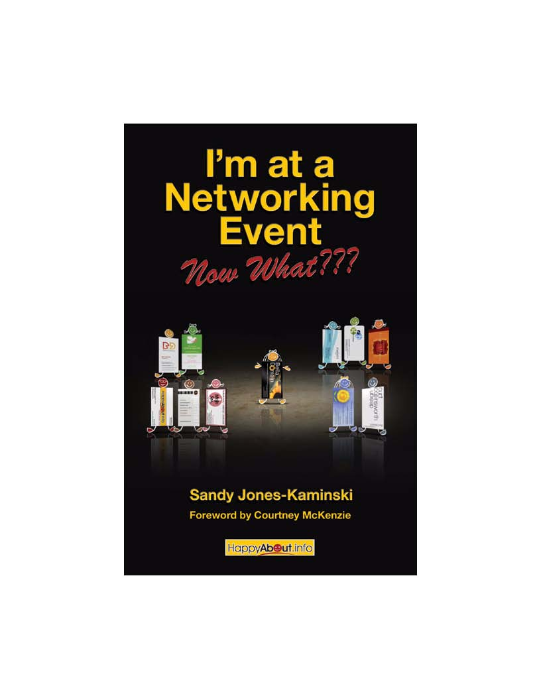
Approved Imagery for Re-Use by Media


Book artwork credit: Keith Kaminski – www.keithkaminski.com
Contact Sandy Jones-Kaminski – sandy@belladomain.com

Select Approved Logos for Re-Use by Media










